**Resumer3D User Manual**

1. **Instruction**
   1. Resumer 3D is compatible with most FDM Prusa style 3D printers on the market, if you find that it does not work well, please get in touch with [resumer3d@gmail.com](mailto:resumer3d@gmail.com), we will contact you within 24 hours.
   2. Resumer 3D only works with printing from SD/TF card, currently it`s not compatible with printing from PC.
   3. Pease put the G-code file on to the SD/TF card base directory, Resumer 3D cannot resume G-code which is in a folder.
2. **Setting**

Before using the Resumer 3D, you need to configure your printer's USB communication baud rate into the module.

* 1. Connect Resumer 3D to your PC via micro USB cable, setup CP2102 driver, download it from <https://github.com/Resumer3d/Resumer3D-module>
  2. Set the baud rate for Resumer 3D by using BoxTool.exe Make sure you unzip the download; You can download it here:

[https://github.com/Resumer3d/Resumer3D-module/raw/master/boxTool.zip](https://github.com/Resumer3d/Resumer3D-module/raw/master/boxTool.zip%20)

1. Ensure Resumer 3D is connected to your PC, Open BoxTool.exe from the extracted folder and click “Refresh” to auto select the com port In this example it is “COM7”

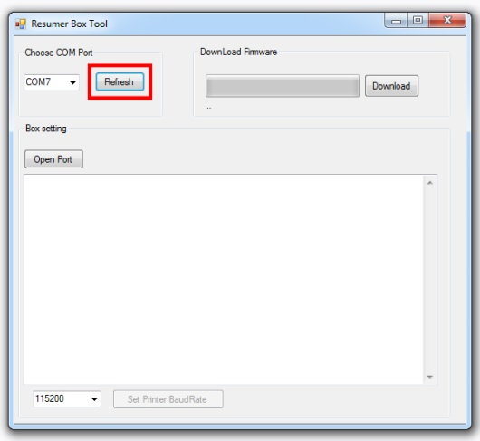

1. Now click “Open Port” Please note that “Open Port” has changed to “Close Port” this means the com port is now active

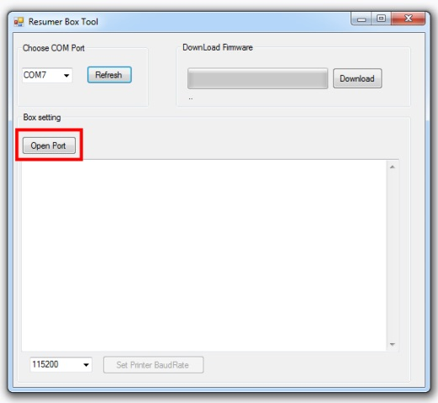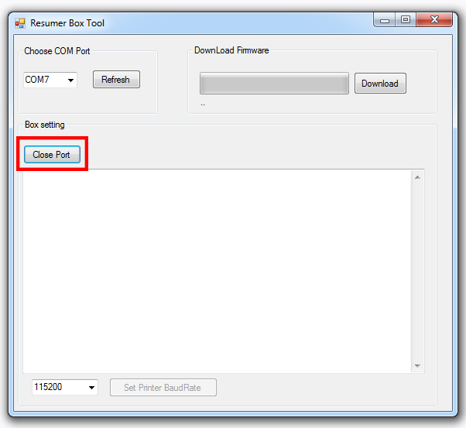

1. Now you need to select or input the Baud rate for your 3D Printer in this example we will use “115200” once you have selected the Baud rate for your printer click “Set Printer BaudRate”

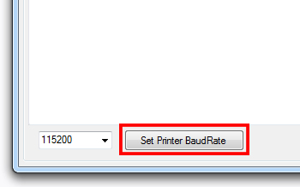

When the Baud Rate is set you will get a message like this

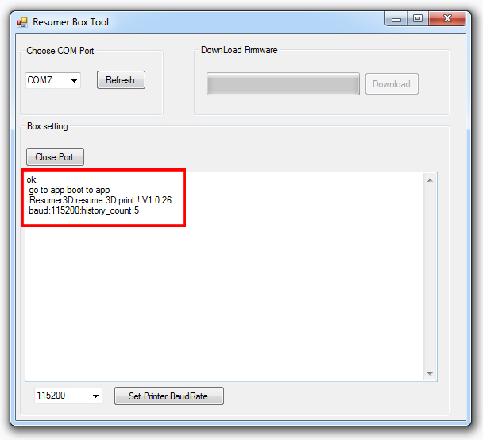

You are now ready to connect the Resumer 3D to your printer

1. **Printing**
   1. Disconnect Resumer 3D from your PC, connect Resumer 3D to your 3D printer Via USB Port cable. If there is no light on, the external power supply is needed with the micro USB cable.
   2. Turn on your 3D printer; keep Resumer 3D connected to the 3D printer while it is printing.
   3. The meaning of the light button



1. Green light flashes: Resume 3D is connecting to the 3D printer, please check if you set baud rete correctly, if Resumer 3D couldn`t connect successfully after 20 seconds.
2. Green light always on: Resumer 3D has connected to your 3D printer successfully.
3. Green light flashes slowly: 3D printer is printing and Resumer 3D is recording data.
4. Red light always on: the printer has stopped and there is printing data that can be resumed.
5. **Resume interrupted printings**
   1. **Resume printings from where it stops.**

If the printer is interrupted by a power outage, or you interrupt the printing intentionally you will see a Red light, press button and the printing will resume automatically.



* 1. **Resume printings from any printed layer**

If you want to resume a failed print because of a nozzle jam or tangled filament, you may need to adjust the Z-axis height of the Nozzle, Resumer 3D will resume printings from user allocated height.

* + 1. **Adjust Z-axis height of Nozzle**

Note: When you reboot the 3D printer, the red light will always be on if there is data to be resumed, while the red light is on, you can adjust the height of the nozzle by using “+”and”-”buttons on Resumer 3D or by the height option on some 3D printers, once you have your desired height press to resume the printing from the proper height. Below are two methods to adjust the height of the nozzle.



**Method 1: “+” and“-” Buttons**

When the lights of the “+”and”-” keys are on that means the height of the nozzle is adjustable.

“+” Button: This will increase Z-axis value of nozzle, by 0.2mm each time you press the button

“-” Button: This will decrease Z-axis value of nozzle, by 0.2mm each time you press the button

When you are sure the Z-axis value of nozzle is as you desire it, press key, Resumer 3D will resume the printing from the height you set.



**Method 2: adjust Z-axis height from 3D printer**

You might also be able to adjust Z-axis height by the height knob on your 3D printer. Note: If your firmware is marilin 1.1.0 or above, you have to home X Y Z before you adjust Z-axis value of the nozzle.

* 1. **Clear history**

If you do not want to resume the interrupted print when you reboot your 3D printer, you can clear the history by pressing “-”and “+”buttons at the same time, while holding “+” and “-“press button, the light of button will turn green from red, this means the history is cleared successfully.



1. **Instruction of toggle switch** 
   1. **Home Z-axis before resuming**



If your 3D printer firmware is marlin 1.1.0 or above, please set the toggle switch to , otherwise Resumer 3D will misalign when it resumes. Because marlin firmware team has revised G92 G-code, home Z-axis is mandatory. Otherwise you need to see it to



* 1. **Not Home Z-axis before resuming**

